Limington Lumber named 2017’s best manufacturer
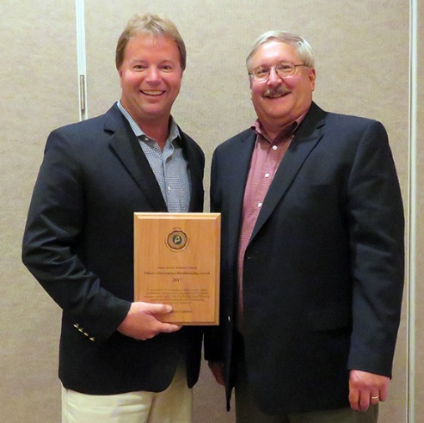
Win Smith and Terry Walters
“It gives me great pleasure to present the 2017 MFPC Manufacturer of the Year Award to Limington Lumber of East Baldwin and its owner Win Smith Jr.,” said Terry Walter, MFPC Board. “It is a pleasure, because during these challenging times for the forestry industry, Limington Lumber has been a great success story. It is not a story that we hear much about as the mill is located in southern Maine and Win is a humble, hardworking individual who tends to business and does not seek out the limelight. When approached about being nominated for the award, Win said he would be honored but that his philosophy was to “fly under the radar.”
“Limington Lumber was established in 1961 by Win’s father (Win Smith Sr.) Win purchased the mill in 2003 and proceeded with a well-planned modernization and expansion. Some of the improvements include a new log carriage with computerized set works, a ring debarker, a bin sorter and automated lumber stacker, additional kilns, a wood boiler for steam production, a complete planer mill, a warehouse and a paved mill yard. The improvements have resulted in an increase in annual production from 10 to 18 million board feet of quality white pine lumber. This staff has also grown to 41 employees.
“Limington Lumber is also a leader in work place safety. When Pat Sirois, Pat Strauch and I visited the mill they both commented about the immaculate housekeeping throughout the facility. I had to assure them that this was standard operating procedure and not a clean-up done for our visit. The company was one of the founding members of the Maine Forest Products Group Trust. This is an industry self-insured worker’s compensation trust that requires rigid standards for participation. It 2008 Limington Lumber was recognized by the Maine Department of Labor as a SHARP certified company. This is a prestigious designation that rewards companies for low injury rates and for compliance with OSHA safety standards.
“In addition to managing a quality sawmill operation, Win is active in the forestry community. He is a member of the Maine Forest Products Council Board of Directors. He is also involved with the Northeast Lumber Manufacturers Association (NELMA), where he has served on many committees and in many capacities. Win has been generous with his time in hosting mill tours for the public and woodland owner groups. He’s been active in the Maine Woodland Owners and he’s also got a very loyal logging contractor base.
“Win, would you please join me at the podium to receive your award, which reads in recognition of outstanding quality, safety performance, progressive management and sustained business growth since 1961.”
“in recognition of outstanding quality control, safety performance, progressive management and sustained business growth since 1961.”
Win Smith joined Walters at the podium and said, “I want to thank the Maine Forest Products Council. I really didn’t expect this award. We’re very honored to be nominated. A lot of the credit has to go to the employees that I have.
“I was very fortunate to be able to work with my dad for about 10 years before he retired and I couldn’t have had a better mentor.
“One of the great things about this industry, especially on the sawmill side, it’s a very open industry. I remember coming back with a wholesale background to Limington Lumber and being very, very green and having a lot of questions about the industry And it was amazing that from Day One how easy it was to talk to somebody like Jim Robbins or, on the spruce side, somebody like Luke Brochu and be able to really get an understanding of some of the principles that helped me run my business.
“As I said, my dad really laid a great foundation that made it very easy for me to go forward. The reality of our company is the strength of our employees and they really have built our company, and our loggers and suppliers. Richard Wing was bringing logs into the yard when I was a boy. It’s been great to sit with Richard over the years and pick his brain. He was a tremendous resource also.
“It’s very encouraging to hear Jim Contino talk about the industry. We have some concerns, but on the pine side production is up and spruce right now is at a pretty good clip. As you look forward there are reasons for optimism.
“I came in as the young guy 24 years ago and now I’m the old guy and it’s amazing. You get to see how Catherine and Jimmy and Alden have stepped in taken Robbins Lumber by the horns and how the Brochu clan, with Jason and Chris, are taking that company upward.
“There are a lot of positives in the industry and one of the strengths is how open we are to sharing information and that makes us all stronger.
“So once again, thank you very much for this award,” Smith said. “It’s very much appreciated.”

